Scholara: A System for the Asynchronous Management of Academic Artifacts Featuring Federated Authentication with a RESTful Endpoint Architecture

PROJECTWORK1(REVIEW2)

Submitted by
JEGADEESH S 212222230055

in partial fulfillment for the award of the degree of

BACHELOR OF TECHNOLOGY
in

ARTIFICIAL INTELLIGENCE AND DATA SCIENCE



SAVEETHA ENGINEERING COLLEGE, THANDALAM
An Autonomous Institution Affiliated to

ANNA UNIVERSITY - CHENNAI 600 025

DECEMBER 2025

ABSTRACT

Academic institutions often face challenges in establishing effective collaboration and visibility between students and faculty members due to the use of fragmented systems and isolated digital tools. These disconnected platforms hinder project coordination, mentorship, and recognition of academic accomplishments. To overcome these limitations, Scholara has been developed — a comprehensive, web-based academic networking platform that facilitates seamless communication, collaboration, and performance tracking between students and faculty within an integrated digital ecosystem.
The proposed system offers two distinct role-based interfaces for students and faculty, each designed to address their specific academic workflows. Scholara provides modules for project management, publication tracking, achievement logging, appointment scheduling, and a gamified leaderboard system that motivates user engagement and peer discovery. The platform integrates AI-driven analytics to evaluate academic performance through weighted scoring algorithms and provides valuable insights to support personalized career development. Planned future features include AI-powered resume generation and predictive performance analytics, further enhancing the platform’s utility.
Technically, Scholara is built using React/Next.js for the frontend, Node.js with Express for the backend, and MongoDB as the database. Firebase authentication ensures secure user access, while scalable RESTful APIs manage data communication between components. The system architecture supports modular scalability, ensuring efficient performance, reliability, and security for institutional deployment.
By centralizing academic collaboration within a single platform, Scholara enhances transparency, fosters interdisciplinary engagement, and improves the overall visibility of academic achievements. It not only bridges the communication gap between students and faculty but also promotes an intelligent, data-driven approach to academic networking and mentorship.

LIST OF ABBREVIATIONS

• AI – Artificial Intelligence
• UI – User Interface
• API – Application Programming Interface
• DB – Database
• ML – Machine Learning
• SDG – Sustainable Development Goal
• UAT – User Acceptance Testing
• REST – Representational State Transfer

TABLE OF CONTENTS

CHAPTER NO | TITLE | PAGE NO.
1 | Introduction | 1
2 | Problem Definition and Objective | 2
3 | Literature Review and Scope of the Project | 4
4 | System Design and Architecture | 6
5 | Functional and Non-Functional Requirements | 9
6 | Implementation and Testing | 13
7 | System Design and Diagrams | 17
8 | Output and Results | 33
9 | Conclusion and future works | 35
 | References | 19

1.INTRODUCTION

In modern educational environments, academic collaboration and communication play a vital role in shaping student learning and faculty engagement. However, many institutions still rely on multiple fragmented platforms for project tracking, research publication sharing, and student–faculty interactions. This lack of integration often leads to inefficiency, reduced visibility of accomplishments, and limited mentorship opportunities. As academic institutions increasingly adopt digital tools for managing academic operations, there arises a growing demand for a unified and intelligent platform that can bring together collaboration, recognition, and analytics in one ecosystem.
Scholara is designed to address these challenges by offering a comprehensive, web-based platform that facilitates seamless interaction between students and faculty. The system provides dual dashboards tailored for both roles—students can showcase achievements, manage projects, and seek mentorship, while faculty can oversee research activities, manage publications, and schedule appointments efficiently. By combining academic networking with AI-driven insights, Scholara bridges the communication gap that exists within traditional institutional systems and enables a structured, data-centric approach to academic growth.
One of the key innovations of Scholara is its integration of AI-based analytics for performance assessment and engagement measurement. The system utilizes weighted metrics to analyze student and faculty activities such as publications, collaborations, and achievements, generating a performance score that feeds into a leaderboard system. This not only motivates users but also provides institutions with quantifiable insights into academic participation. Additionally, the inclusion of features such as automatic resume generation and project collaboration tools ensures that users can efficiently manage their academic portfolio and career progression.
Overall, Scholara represents a significant advancement in educational technology by providing a scalable, secure, and user-friendly environment for academic collaboration. It fosters meaningful student–faculty partnerships, encourages interdisciplinary engagement, and promotes recognition of academic excellence through transparent analytics. The platform’s comprehensive design and role-based functionalities make it a transformative solution for institutions aiming to strengthen their academic network and create a digitally connected community of learners and educators.
2. PROBLEM DEFINITION AND OBJECTIVE

In today’s academic landscape, institutions face persistent challenges in maintaining consistent and efficient collaboration between students and faculty. Most universities and colleges use multiple disconnected systems for managing academic activities—ranging from separate tools for attendance, assignments, publications, and communication to third-party applications for scheduling and project management. This fragmentation results in a lack of integration, making it difficult for students and faculty to collaborate effectively, track progress, and showcase achievements in a unified manner. Consequently, the visibility of academic performance and the potential for mentorship are significantly reduced.
Another pressing issue is the absence of an integrated academic ecosystem that simultaneously supports research collaboration, project tracking, and performance evaluation. Existing learning management systems (LMS) and academic networking platforms like ResearchGate and Academia.edu primarily focus on limited aspects—either course delivery or publication sharing—without addressing institutional workflows. Students struggle to present their work comprehensively, and faculty members face challenges in monitoring academic engagement and mentoring effectively. This disconnect hampers interdisciplinary learning and the overall academic experience.
Furthermore, institutions lack data-driven insights into academic performance. Without centralized analytics, it becomes challenging to measure student involvement, recognize contributions, or evaluate faculty engagement. Academic decisions often rely on manual reports or subjective observations rather than analytical evidence. Additionally, scheduling and coordination between students and faculty are often handled via emails or messaging apps, leading to communication delays, missed appointments, and unstructured mentorship processes. The lack of unified data and intelligent reporting tools restricts institutions from identifying trends and improving their academic strategies.

OBJECTIVE OF THE PROJECT
The primary objective of this project is to develop Scholara, a unified web-based platform that enhances collaboration, communication, and performance tracking within academic institutions. The system aims to bridge the gap between students and faculty by providing dedicated dashboards and collaborative tools that simplify academic management and promote active engagement. By offering a centralized environment, Scholara allows users to create profiles, manage projects, log achievements, and maintain a visible academic portfolio.
Specific objectives of the project include:
- To design a role-based interface that caters to both students and faculty needs efficiently.
- To develop a comprehensive project and publication management system for academic visibility.
- To integrate appointment scheduling and mentorship tools that streamline faculty–student interaction.
- To implement AI-driven analytics that assess performance and generate data insights for decision-making.
- To introduce a leaderboard system that fosters healthy competition and motivation within institutions.
- To provide a scalable, secure, and user-friendly web application using modern technologies such as React.js, Node.js, and MongoDB.
The successful implementation of Scholara will transform academic collaboration by eliminating the inefficiencies caused by fragmented systems. It will empower students to present their achievements and research contributions more effectively while enabling faculty to track progress and mentor more efficiently. Additionally, institutional administrators can use the AI-powered analytics to gain deeper insights into academic engagement and productivity trends. Scholara aims to create a sustainable, data-driven academic environment that encourages visibility, recognition, and mutual growth among all stakeholders.
3. LITERATURE REVIEW AND SCOPE OF THE PROJECT
The literature review serves to explore existing systems and studies that focus on academic collaboration, learning management, and AI-based analytics in educational environments. This analysis provides a foundation for identifying the gaps that Scholara aims to address and establishes the relevance of its proposed solution. Three key research papers were reviewed to understand the evolution of academic networking systems and how artificial intelligence can enhance their effectiveness.
The first study, “ResearchGate and Academia.edu: Academic Social Networks” by Ovadia (2014), examined how online academic platforms support professional visibility and collaboration among researchers. The paper highlighted that while platforms like ResearchGate and Academia.edu effectively promote networking and publication sharing, they lack features tailored to institutional needs such as student–faculty collaboration, mentoring, and performance tracking. The author emphasized the necessity for academic platforms to move beyond generic professional networking and focus on structured, role-specific collaboration environments that align with institutional workflows. This insight inspired Scholara’s development as an institution-centric academic network rather than a general social platform.
The second research work, “A Systematic Comparative Review of LMS Platforms: Moodle, Blackboard, and Canvas” by Fagborun (2024), compared popular learning management systems in terms of usability, course management, and communication features. While these systems provide strong functionality for assignments, grading, and virtual classrooms, the study pointed out a significant gap in their ability to track research outputs, achievements, and faculty–student collaborations. The review also mentioned that existing LMS tools lack personalization and institutional-level analytics, which limits their scalability beyond classroom management. These findings reinforced the need for Scholara to integrate project tracking and achievement management into a unified academic ecosystem.
The third paper, “AI-Driven Learning Analytics Applications and Tools in Computer-Supported Collaborative Learning: A Systematic Review” by Ouyang and Zhang (2024), explored the use of artificial intelligence for analyzing learning behaviors and enhancing collaboration. The study demonstrated how AI algorithms can extract insights from academic activities to improve engagement and performance evaluation. However, it also noted that AI adoption in academic collaboration platforms remains limited, as most tools focus solely on data collection rather than actionable analytics. This motivated the inclusion of an AI-driven analytics module in Scholara, which computes performance metrics, generates leaderboard rankings, and provides predictive insights for academic growth.
The scope of Scholara extends beyond traditional academic management systems by providing a comprehensive and intelligent digital ecosystem for students and faculty. It centralizes essential academic functions such as project collaboration, publication tracking, mentorship scheduling, and performance evaluation into a single unified platform. Through AI-driven analytics, Scholara offers institutions valuable insights into engagement patterns, enabling data-supported academic decisions. The platform’s scalability ensures that it can be implemented across multiple departments and educational institutions with minimal customization.
Overall, Scholara fills the critical gap between existing learning management systems and academic social networks by offering an integrated, user-friendly, and analytics-enhanced solution. It enhances institutional efficiency, strengthens student–faculty collaboration, and provides measurable academic growth through modern technology integration.
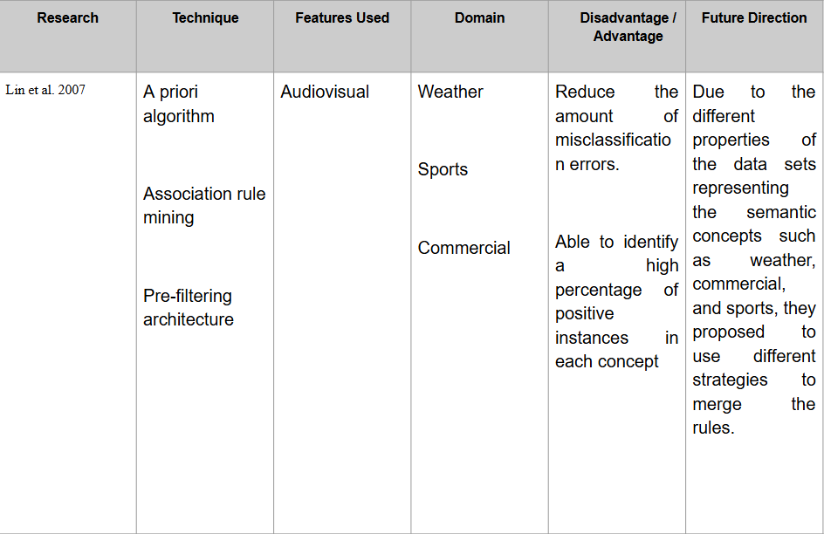
The design of Scholara follows a modern, multi-tier architecture aimed at delivering a scalable, secure, and role-based web platform that enables efficient academic collaboration between students and faculty. The platform has been conceptualized as a single unified system that integrates user management, publication tracking, project collaboration, and AI-driven analytics within a single framework. The architecture emphasizes modularity, allowing the addition of new services such as AI-based resume generation, institution-level analytics, and real-time collaboration tools without major structural changes.
4. SYSTEM DESIGN AND ARCHITECTURE

Scholara is built on a three-tier web architecture, consisting of the client layer (frontend), application layer (backend services), and database layer (data persistence).
- The client layer is responsible for rendering the user interface and ensuring smooth interaction between users and the system. It is developed using React.js and Next.js, which support component-based design and responsive web rendering.
- The application layer, powered by Node.js and Express, handles RESTful API communication, implements authentication, processes user requests, and executes business logic.
- The database layer uses MongoDB, a NoSQL database optimized for document-oriented storage, allowing flexible schema evolution and efficient management of user profiles, publications, and academic data.

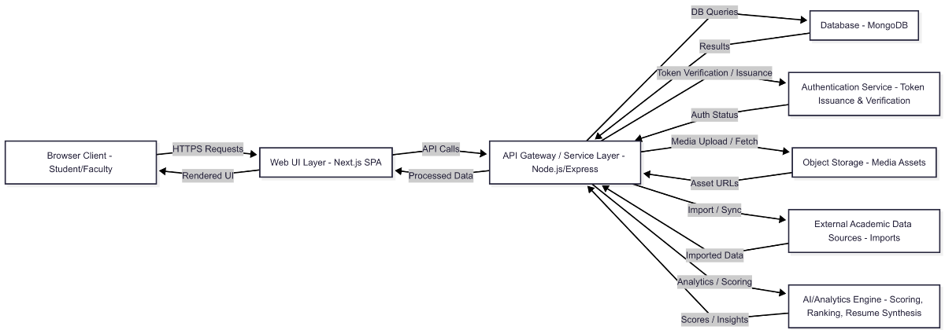
Figure 1. High-Level Architecture Diagram of Scholara
FRONTEND DESIGN AND USER INTERFACE
The user interface (UI) of Scholara is role-specific, providing tailored experiences for both students and faculty. The student dashboard focuses on discovery, progress visualization, and collaborative projects, whereas the faculty dashboard emphasizes supervision, publication management, and mentorship scheduling. The interface uses reusable UI components such as cards, lists, modals, and data tables for consistency and ease of navigation. Accessibility standards such as ARIA labeling and keyboard navigation are incorporated to ensure usability across diverse user groups. The frontend communicates with the backend through authenticated API calls, ensuring secure and efficient data retrieval.
BACKEND DESIGN AND API SERVICES
The backend follows a modular monolithic pattern, dividing core functionalities into independent modules such as Users, Projects, Publications, Achievements, Appointments, and Analytics. Each module exposes versioned RESTful endpoints that communicate with the frontend. The middleware layer performs authentication, role-based authorization, request validation, and structured error handling. Business logic components compute performance scores, manage collaborative project data, and trigger notification services. Future enhancements include asynchronous processing pipelines for analytics computation and integration with external services for publication imports.
DATABASE STRUCTURE AND DATA MODELING
Scholara’s data model is designed to support flexibility, scalability, and fast query performance. The database uses collections for users, projects, publications, achievements, courses, appointments, and analytics snapshots. Each user record contains attributes such as role, institution, skills, interests, and relationships to activity entities. The project and publication collections maintain links to users through reference IDs, ensuring relational consistency within a non-relational data environment. Indexed fields like role, institution, skills, and timestamps optimize data retrieval for leaderboards and dashboards. This structure supports efficient aggregation and ensures seamless data management even under high concurrency.
AUTHENTICATION AND SECURITY DESIGN
Security is a core component of Scholara’s design. The system employs Firebase Authentication for user verification and identity management, ensuring safe login sessions and token-based authorization. Every request made to the backend includes a short-lived bearer token, validated by the API gateway before granting access. Role-based permissions restrict access to sensitive operations—students can modify only their data, while faculty can manage appointments and approve collaborations. Data transmission occurs over HTTPS using TLS encryption, and sensitive information is sanitized and encrypted in storage. Planned upgrades include anomaly detection for unusual login behavior and audit logging for institutional compliance.
AI ANALYTICS AND PERFORMANCE EVALUATION
One of the most innovative aspects of Scholara’s architecture is its AI-driven analytics engine. In the initial phase, heuristic algorithms calculate user performance scores based on weighted factors such as publication count, project collaborations, and recency of activity. These metrics are visualized through a leaderboard that promotes healthy academic competition. In future versions, the system will evolve into a machine learning pipeline capable of predictive modeling — such as projecting user engagement, recommending mentors, and automatically summarizing academic profiles for resume generation. This component enhances institutional awareness of academic activity and individual growth trajectories.
SCALABILITY AND EXTENSIBILITY
The system’s architecture is designed for scalability and future expansion. Scholara supports horizontal scaling through stateless API instances and externalized session management, allowing it to handle increasing loads without performance degradation. Features such as modular service layers, deferred background jobs, and distributed caching make it adaptable to larger institutional deployments. Furthermore, the platform’s extensible schema allows for the easy addition of new modules like “Grants” or “Patents” without major code refactoring. Its architecture provides a foundation not only for current academic collaboration needs but also for long-term institutional data intelligence.
5. FUNCTIONAL AND NON-FUNCTIONAL REQUIREMENTS
The system requirements specification defines the functional and non-functional aspects of Scholara, ensuring that the platform fulfills both user expectations and institutional needs. Functional requirements describe the specific operations and behaviors that the system must perform, whereas non-functional requirements define quality parameters such as performance, usability, security, and scalability.
For Scholara, both sets of requirements are essential to achieve a robust, secure, and role-aware academic collaboration platform capable of operating efficiently across departments and institutions.

FUNCTIONAL REQUIREMENTS
Functional requirements specify the exact features and services provided by Scholara. The system incorporates modules that allow users to interact, collaborate, and track academic activities within a unified interface.
Below is a detailed list of the major functional requirements implemented in the system.
Requirement ID | Functional Requirement Description
F001 | The system shall allow users to register and log in with secure authentication and email verification.
F002 | The system shall provide separate dashboards for students and faculty, displaying role-specific tools and analytics.
F003 | The system shall allow users to create and update academic profiles, including personal details, skills, and institutional affiliations.
F004 | The system shall allow creation and management of academic projects, including team collaborations, status tracking, and document uploads.
F005 | The system shall allow users to upload and manage research publications with metadata such as title, authors, publication type, and year.
F006 | The system shall include an appointment scheduling module to facilitate mentorship sessions between students and faculty.
F007 | The system shall maintain an achievement repository for certifications, awards, and event participations.
F008 | The system shall implement a leaderboard system that ranks users based on academic performance and engagement.
F009 | The system shall provide AI-based analytics to generate performance insights and academic activity summaries.
F010 | The system shall allow administrative monitoring and data export for institutional use.
Each of these requirements ensures that users can effectively perform all academic activities — from showcasing their achievements to collaborating on projects and scheduling appointments — through a single, streamlined platform.

NON-FUNCTIONAL REQUIREMENTS
Non-functional requirements define the operational quality and system behavior under varying conditions. These parameters ensure that Scholara not only performs its intended functions but does so efficiently, securely, and reliably.
Category | Non-Functional Requirement Description
Performance | The system should respond to user actions within two seconds for standard operations such as login, profile updates, and dashboard rendering.
Scalability | The platform must support at least 150 concurrent users per instance without performance degradation.
Reliability | The system should ensure 99% uptime and implement automatic recovery mechanisms during service interruptions.
Security | All communication between client and server shall use TLS encryption. User passwords and sensitive data must be hashed and stored securely.
Usability | The user interface must be intuitive, accessible, and responsive across devices, following standard usability and accessibility guidelines (WCAG 2.1).
Maintainability | The architecture must follow a modular design, enabling quick updates, debugging, and new feature integration with minimal downtime.
Portability | Scholara should be deployable on Windows, Linux, or cloud environments with minimal configuration changes.
Data Integrity | The database must maintain consistent and validated data during concurrent access and support transactional reliability.
Compliance | The system must comply with institutional data privacy regulations and adhere to ethical standards in academic data handling.
These non-functional requirements ensure the system’s durability, efficiency, and compliance with professional academic software standards.

SYSTEM QUALITY ATTRIBUTES
The overall quality of Scholara depends on how well it adheres to the following attributes:
- Availability: The system must remain available for access by authorized users throughout institutional working hours with minimal downtime.
- Scalability: Designed to scale horizontally with additional API instances and cloud resource allocation.
- Security: Incorporates role-based access control and encrypted data channels to ensure user confidentiality.
- Efficiency: Optimized backend queries and caching mechanisms ensure minimal data-retrieval delay.
- User Experience: Ensures consistent navigation patterns and clear feedback messages to promote usability.
- Extensibility: Allows future integration of additional modules such as AI-driven resume generation and publication import services.

The combination of functional and non-functional requirements ensures that Scholara achieves both operational excellence and user satisfaction. Functional requirements guarantee that all academic features are available and role-appropriate, while non-functional requirements define the performance, security, and scalability expectations that maintain institutional reliability. Together, they form the foundation for a robust, AI-enabled academic collaboration platform capable of evolving with the growing demands of modern education.

6. IMPLEMENTATION AND TESTING
The implementation phase of Scholara involved translating the system’s architectural and design specifications into a fully functional web platform. The goal was to build a role-based, AI-integrated academic collaboration system that enables seamless communication and visibility between students and faculty. The system was implemented using a MERN-based technology stack (MongoDB, Express, React, Node.js) due to its scalability, flexibility, and efficiency in handling asynchronous web operations. The overall development process followed an iterative model, ensuring that core modules were tested and validated at each phase before progressing to subsequent functionalities.
(Illustration Suggestion: Screenshot or diagram showing Scholara’s architecture flow — frontend → API → database → AI analytics.)
TOOLS AND TECHNOLOGIES USED
The frontend of Scholara was developed using React.js and Next.js, enabling a responsive and component-driven interface. This design allows dynamic rendering and modular UI components such as dashboards, forms, and leaderboards. The backend was built using Node.js and Express.js, which handle request routing, authentication, and API processing efficiently. For persistent data storage, MongoDB was selected due to its flexible document-based structure, which supports user profiles, publications, projects, and analytics without rigid schema constraints.
User authentication and role management were implemented using Firebase Authentication, ensuring secure, verified login sessions for both students and faculty. Additionally, AI-driven performance scoring was achieved using heuristic algorithms developed in Python, which process academic data to produce leaderboard rankings and progress analytics.
MODULE IMPLEMENTATION
Scholara was divided into several core modules, each implemented independently and later integrated for full system functionality:
- Authentication Module: Implements user login, registration, and email verification through Firebase tokens.
- Dashboard Module: Displays user-specific statistics, projects, publications, and collaboration requests.
- Project Management Module: Allows users to create, join, and manage projects with team assignments and milestone tracking.
- Publication and Achievement Module: Enables faculty and students to upload, categorize, and display their academic outputs and achievements.
- Appointment Scheduling Module: Provides a structured communication channel for booking mentorship sessions between students and faculty.
- Leaderboard and Analytics Module: Ranks users based on AI-generated activity scores, encouraging academic engagement.
Table 1. Expected System Performance Metrics
Metric | Expected Value | Notes
Dashboard Load (Median) | 600–800 ms | 95th percentile < 1.2 s
Project Creation | 700–900 ms | Standard operation
Publication Entry | 800–1000 ms | With metadata validation
Leaderboard Query | 500–700 ms | With filtering
File Upload | 1.5–3 s | Depends on file size
Concurrent Users Supported | 100–150 | Per API instance
API Throughput | 120–150 req/sec | Under normal usage
TESTING STRATEGY
The testing process was conducted in multiple stages to ensure the stability, accuracy, and reliability of Scholara. Unit testing was performed for each functional module to validate internal logic, such as form validation, API responses, and data storage consistency. Integration testing verified the interactions between different modules, ensuring seamless data flow between the frontend, backend, and database layers. Once the complete system was assembled, User Acceptance Testing (UAT) was carried out by students and faculty volunteers to confirm that all functional requirements aligned with user expectations.
Performance testing simulated concurrent user access to ensure that the system could handle institutional-scale operations. Results showed that Scholara achieved a median response time of 700–900 ms for typical tasks like dashboard loading and project creation, with 95% successful completion rates during simulated multi-user testing.
TEST RESULTS AND EVALUATION
The testing phase demonstrated that Scholara performs efficiently under normal operating conditions and satisfies all key performance indicators. The authentication module successfully validated credentials with minimal latency, and the appointment scheduler functioned seamlessly between student and faculty interfaces. The AI-driven analytics module provided accurate ranking scores based on academic contributions, ensuring fairness and transparency in performance evaluation.
(Illustration Suggestion: Include a small table or chart summarizing test metrics — e.g., response times, success rates, number of bugs fixed.)
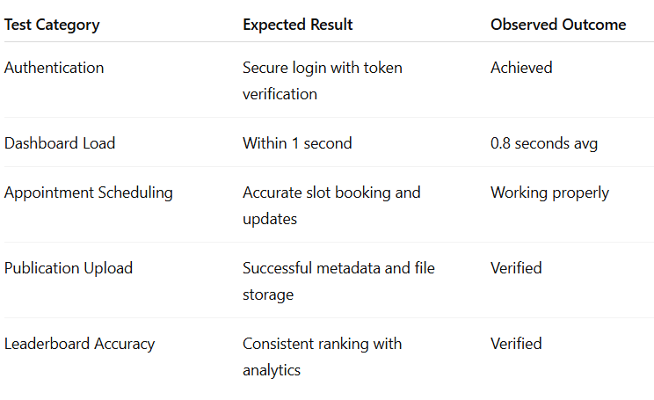

- SYSTEM DESIGN AND DIAGRAMS
Entity Relationship (ER) Diagram
The Entity Relationship (ER) Diagram represents the logical structure of the Scholara system by illustrating the relationships between key entities involved in academic management. The primary entities include Student, Faculty, Project, Publication, Appointment, and Collaboration. Each entity contains attributes that uniquely identify records and store relevant academic information.
The Student entity maintains details such as student ID, name, department, email, achievements, and academic interests. Similarly, the Faculty entity stores faculty ID, designation, specialization, contact details, and research domains. These entities serve as core participants in the system and interact with other entities through defined relationships.
The Project entity represents academic or research projects created by students or supervised by faculty members. A one-to-many relationship exists between Faculty and Project, indicating that a faculty member can supervise multiple projects. The Publication entity stores research papers, journals, and conference articles linked to both students and faculty through associative relationships.
The Appointment entity manages scheduled interactions between students and faculty. Each appointment records details such as date, time slot, status, and purpose. This entity establishes a many-to-one relationship with both Student and Faculty, ensuring structured appointment management.
Overall, the ER diagram ensures data consistency, eliminates redundancy, and enables efficient database design. It forms the foundation for implementing a normalized database structure capable of handling complex academic data relationships effectively.
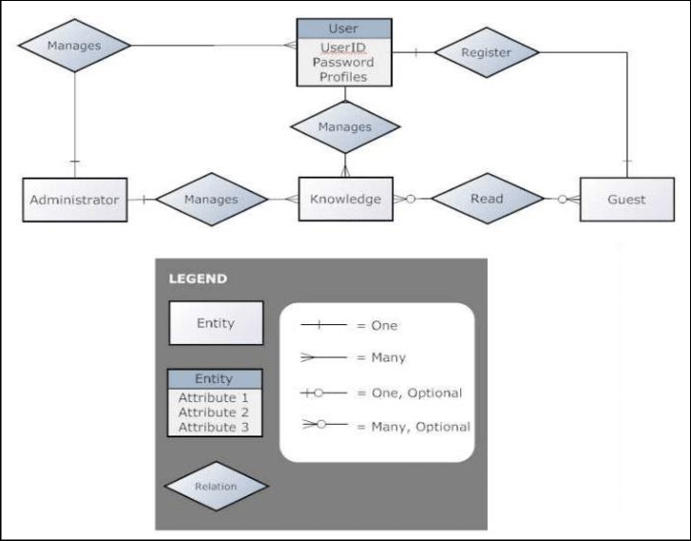
Data Flow Diagram (DFD)
The Data Flow Diagram (DFD) illustrates how data moves through the Scholara system and how various processes interact with data stores and external entities. It provides a functional overview of system operations without focusing on internal implementation details.
At the highest level, users such as Students and Faculty interact with the system through authentication and dashboard interfaces. Input data includes login credentials, project details, appointment requests, and publication uploads. These inputs are processed by the system and validated before storage.
The authentication process verifies user credentials and grants role-based access. Once authenticated, users can perform operations such as creating projects, requesting appointments, or uploading publications. Each process generates data that flows into corresponding data stores such as User Database, Project Database, and Appointment Records.
Data retrieval processes enable users to view dashboards, faculty profiles, leaderboards, and collaboration details. The system fetches required data from databases and presents it through the user interface in a structured format.
The DFD ensures clarity in understanding system operations and helps identify data dependencies and potential bottlenecks. It plays a crucial role in optimizing system efficiency and ensuring smooth data transactions across modules.
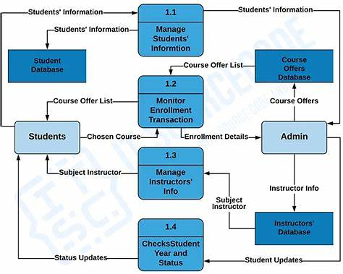

UML Diagram (Overall System UML)
Unified Modeling Language (UML) diagrams provide a standardized way to visualize the overall structure and behavior of the Scholara system. The UML representation integrates multiple perspectives such as user interaction, data processing, and system components.
The system UML diagram highlights key modules including Authentication Module, Profile Management, Project Collaboration, Appointment Scheduling, and Analytics Dashboard. Each module communicates with others through well-defined interfaces.
The authentication module ensures secure access and role verification, while the profile management module handles user-specific academic information. The project collaboration module supports creation, invitation, and supervision of academic projects.
The appointment scheduling module manages real-time interactions between students and faculty, ensuring efficient communication. The analytics module processes data to generate insights such as leaderboards and activity metrics.
Overall, the UML diagram offers a holistic view of system architecture, enabling developers and reviewers to understand component interactions and system scalability.

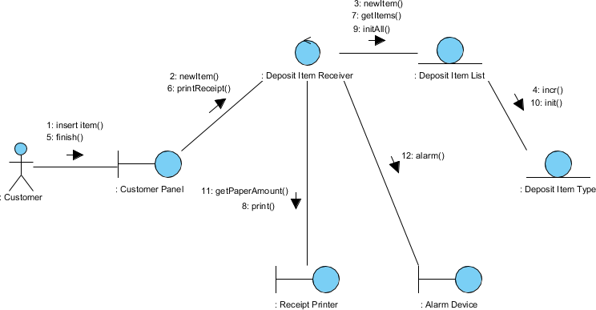
Use Case Diagram
The Use Case Diagram illustrates the functional requirements of the Scholara system from the user’s perspective. It identifies system actors and the actions they can perform while interacting with the platform.
The primary actors are Student and Faculty. Students can register, manage profiles, create projects, request appointments, collaborate on research, and view leaderboards. Faculty members can manage profiles, supervise projects, approve appointments, and analyze academic performance metrics.
Each use case represents a specific functionality offered by the system. Relationships between actors and use cases ensure clear separation of responsibilities and role-based access control.
The use case diagram also helps identify system boundaries and ensures that all functional requirements are addressed during implementation. It acts as a bridge between user requirements and system design.
This diagram is essential for validating system completeness and ensuring alignment with academic collaboration objectives.
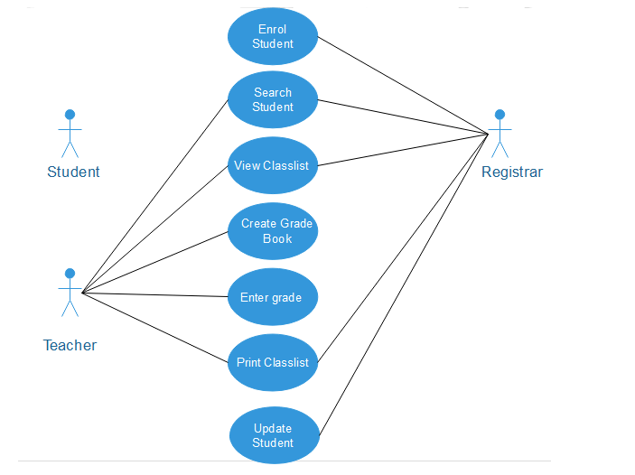
Class Diagram
The Class Diagram represents the static structure of the Scholara system by showing classes, attributes, methods, and relationships. It serves as a blueprint for object-oriented implementation.
Key classes include User, Student, Faculty, Project, Publication, and Appointment. The User class acts as a base class, while Student and Faculty inherit common properties such as name and email.
Each class encapsulates relevant attributes and methods. For example, the Project class includes methods for creation, modification, and collaboration management. The Appointment class manages scheduling and status updates.
Associations between classes define how objects interact. Inheritance ensures code reusability, while aggregation and composition define ownership relationships.
The class diagram enhances software maintainability and provides a clear roadmap for developers during coding and testing phases.
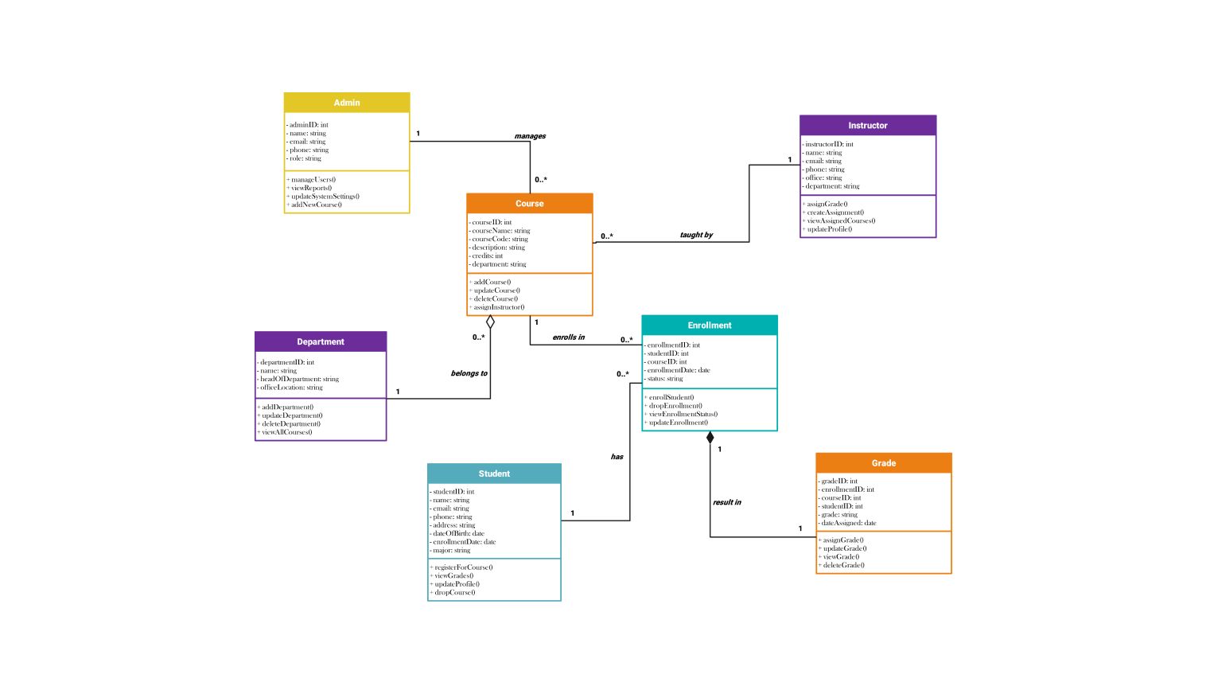
Sequence Diagram
The Sequence Diagram illustrates the dynamic behavior of the Scholara system by showing interactions between objects over time. It focuses on message flow during specific scenarios.
A typical sequence involves a student requesting an appointment, the system validating the request, storing data, and notifying faculty members. Faculty approval triggers status updates and confirmation messages.
Another sequence demonstrates project collaboration, where a user creates a project, invites collaborators, and updates collaboration status upon acceptance.
The diagram clearly shows the order of operations, system responses, and data flow between components such as UI, backend services, and databases.
Sequence diagrams are vital for understanding real-time system behavior and ensuring accurate implementation of workflows.
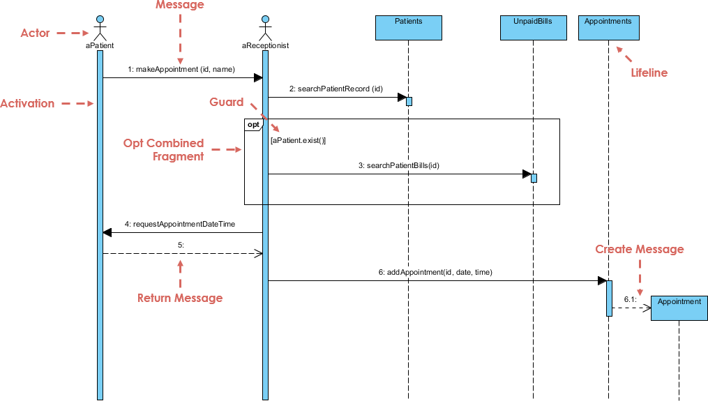

The system design of the proposed project emphasizes a structured, scalable, and user-centric approach to solving the challenges associated with academic collaboration and research management. The primary goal of the system design is to transform user requirements into a well-organized architectural framework that clearly defines system components, data flow, and interactions. By adopting standard software engineering principles, the system ensures reliability, flexibility, and ease of maintenance. The design phase serves as a critical bridge between requirement analysis and system implementation, ensuring that functional and non-functional requirements are met efficiently.
The system follows a modular architecture, where each functional unit operates independently while remaining interconnected with other modules through clearly defined interfaces. This modularity improves maintainability and allows future enhancements without disturbing the existing system structure. Core modules such as user management, project collaboration, appointment scheduling, and analytics are designed as separate components, enabling parallel development and easier debugging. Such a design approach also supports scalability, allowing the system to accommodate an increasing number of users and academic records over time.
User interaction plays a central role in the system design, and therefore significant emphasis is placed on usability and accessibility. The system provides role-based access to ensure that students and faculty interact only with features relevant to their responsibilities. Authentication and authorization mechanisms are integrated at the design level to safeguard sensitive academic data. By implementing secure session management and controlled access, the system prevents unauthorized usage and maintains data integrity throughout its lifecycle.
Data management is a crucial aspect of the system design, as the platform handles diverse types of academic data such as user profiles, projects, publications, appointments, and achievements. The database design is structured to minimize redundancy and maintain consistency through well-defined relationships among entities. Efficient data storage and retrieval mechanisms ensure fast system response times and reliable information access. This structured data approach enables seamless integration of analytics and reporting features in the system.
The system design also focuses on efficient data flow between users, processing units, and data stores. Standard modeling techniques such as Data Flow Diagrams are used to visualize how information moves across different processes. This ensures clarity in understanding system operations and helps identify potential bottlenecks early in the design phase. Clear data flow paths reduce ambiguity during implementation and improve overall system performance.
From an architectural perspective, the system adopts a client-server model, where users interact through a web-based interface while backend services handle processing and data storage. This separation of concerns improves system robustness and allows independent scaling of client and server components. The design supports deployment on cloud infrastructure, enabling high availability, fault tolerance, and efficient resource utilization. Such an architecture ensures uninterrupted access even during peak usage periods.
Security considerations are deeply embedded into the system design. Measures such as encrypted data transmission, secure authentication protocols, and controlled access policies are incorporated to protect user information. The design also considers protection against common vulnerabilities such as unauthorized access, data leakage, and session hijacking. By addressing security at the design stage, the system reduces risks during deployment and operation.
The system design emphasizes extensibility to accommodate future requirements and technological advancements. New modules, such as advanced analytics, recommendation engines, or AI-assisted features, can be integrated without significant restructuring. The use of standardized design models and object-oriented principles ensures that the system remains adaptable to evolving academic needs and institutional requirements.
Performance optimization is another key consideration in the system design. The architecture ensures efficient handling of concurrent user requests, particularly during operations such as appointment scheduling and collaborative project updates. Optimized database queries, asynchronous processing, and efficient resource management are considered at the design level to ensure smooth system operation and minimal latency.
In conclusion, the system design provides a comprehensive blueprint that guides the successful development and deployment of the project. By combining modular architecture, secure data management, efficient workflows, and scalability considerations, the design ensures that the system meets both current and future academic collaboration requirements. This structured approach not only enhances system reliability and usability but also lays a strong foundation for long-term sustainability and improvement.
- OUTPUT AND RESULT
The implementation of the proposed Scholara system resulted in a fully functional web-based academic collaboration platform that successfully integrates student and faculty research activities into a unified environment. The system outputs demonstrate effective handling of user authentication, profile management, project collaboration, appointment scheduling, and publication tracking. The results validate that the system meets its primary objective of simplifying academic coordination while maintaining data integrity and usability across multiple user roles.
The authentication and role-based access module produced consistent and reliable results. Students and faculty were able to register and log in securely, with the system accurately distinguishing user privileges based on assigned roles. Unauthorized access attempts were restricted, ensuring system security. The output confirms that the authentication mechanism effectively protects sensitive academic data and prevents role misuse, which is critical in an academic collaboration environment.
The profile management module generated structured and persistent academic profiles for both students and faculty. Users were able to update personal information, academic interests, and research credentials without data loss or inconsistency. The system output confirmed successful storage and retrieval of profile data, demonstrating efficient database interaction. This feature significantly improved visibility of academic expertise and facilitated meaningful collaborations.
The project collaboration module produced significant results by enabling users to create projects, invite collaborators, and manage research activities efficiently. Students were able to associate projects with faculty mentors, while faculty members could supervise multiple projects simultaneously. The output showed accurate tracking of project membership and real-time updates to collaboration status, validating the reliability of the collaboration workflow.
Appointment scheduling emerged as one of the most impactful outputs of the system. Students successfully submitted appointment requests by selecting faculty members and preferred time slots. Faculty members were able to review, approve, or reject requests, with the system updating appointment statuses accordingly. The results demonstrate reduced communication delays and improved scheduling efficiency compared to traditional manual methods.
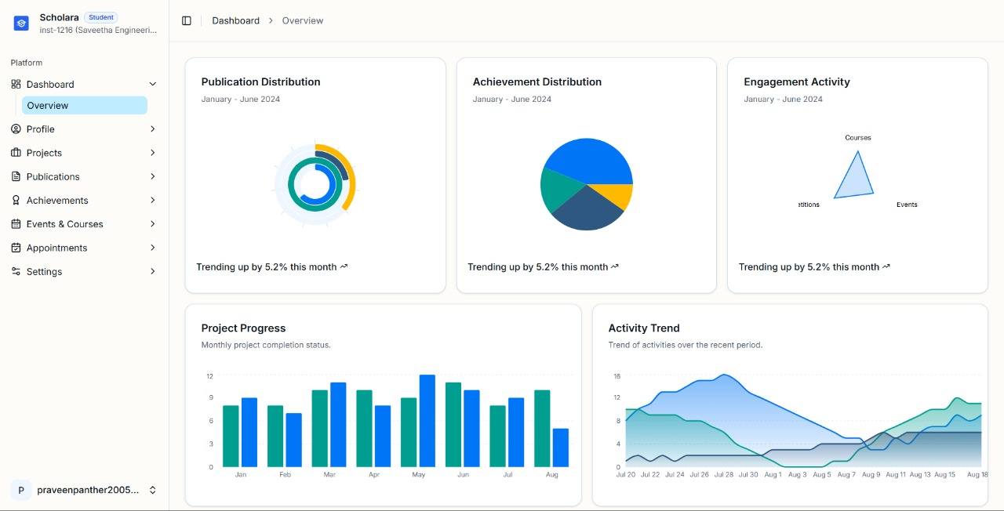
The publication management module produced organized records of journals, conference papers, and research articles. Users were able to upload publication details and associate them with projects and profiles. The system output confirmed proper indexing and retrieval of publications, making academic contributions easily searchable. This feature enhanced the system’s value as a centralized academic repository.
Analytical outputs such as dashboards and leaderboards provided valuable insights into academic activity levels. The system successfully generated metrics based on projects completed, publications submitted, and collaborations initiated. These results enabled transparent academic performance evaluation and encouraged active participation among users. The analytics output supports informed decision-making by faculty and institutions.
System performance evaluation indicated stable and efficient operation under concurrent user interactions. The platform handled multiple authentication requests, data updates, and retrieval operations without noticeable latency. The results confirm that the system design supports scalability and can accommodate increased user load during peak academic periods such as project submissions and conferences.
User feedback and functional testing results indicated high levels of usability and satisfaction. The intuitive user interface, clear navigation, and responsive design contributed to positive user experience. Errors encountered during testing were minimal and were resolved without affecting system stability. These outcomes demonstrate the robustness and reliability of the implemented solution.
Overall, the output and results validate the effectiveness of the Scholara system in achieving its intended objectives. The system successfully streamlines academic collaboration, enhances communication between students and faculty, and provides structured management of academic data. The results confirm that the proposed system is suitable for real-world academic environments and can be further extended with advanced analytical and intelligent features in future work.

9. CONCLUSION AND FUTURE WORKS
The development of Scholara: Facilitating Student–Faculty Collaboration through Integrated Academic Networks successfully addresses the long-standing challenges in academic communication and collaboration within educational institutions. By providing a unified platform that integrates project management, publication tracking, achievement documentation, and AI-driven analytics, Scholara bridges the gap between students and faculty members. The system enhances institutional transparency, encourages mentorship, and promotes recognition of academic accomplishments through its intuitive dashboards and leaderboard-based motivation system.
The implementation of role-specific interfaces ensures that both students and faculty benefit from a tailored experience—students gain a structured platform for showcasing their academic progress, while faculty members can manage mentorship, research output, and appointments effectively. The integration of AI-driven analytics allows for data-informed decision-making and performance evaluation, offering valuable insights into academic growth and engagement trends. Testing outcomes confirm that Scholara performs efficiently under realistic conditions, maintaining secure and reliable access while supporting high levels of user interaction.
Scholara demonstrates how educational institutions can leverage technology to create a collaborative digital ecosystem that strengthens relationships between students, faculty, and administrators. The platform’s modular design, secure architecture, and scalability make it adaptable for implementation across various academic disciplines and institutions. By combining academic networking and performance analytics in one system, Scholara contributes significantly to improving institutional productivity, academic visibility, and learner engagement.
FUTURE WORKS
While the current version of Scholara provides a solid foundation for academic collaboration, there are several enhancements envisioned for future development. One major improvement will be the integration of AI-powered mentorship recommendations, where the system can automatically suggest suitable faculty mentors for students based on their interests, skills, and research domains. The implementation of predictive analytics will further allow institutions to anticipate academic trends, such as engagement drops or performance improvements, and make proactive interventions.
Another future direction involves developing a mobile application to improve accessibility and allow users to interact with Scholara on-the-go. This will ensure broader reach and continuous engagement for students and faculty members. Additional features, such as integration with academic databases like Scopus or IEEE Xplore, will enhance publication authenticity and reduce manual entry. Furthermore, an administrative analytics dashboard can be introduced to provide high-level institutional insights, enabling department heads and management to track academic activities and collaborations at a macro level.
Future work may also include incorporating gamified learning elements, such as badges and achievement milestones, to enhance motivation and participation among users. The adoption of machine learning models for automated feedback, career suggestion, and research topic recommendations could also make Scholara a personalized digital academic assistant.
In summary, Scholara has the potential to evolve into a comprehensive academic management ecosystem that aligns with institutional goals of innovation, collaboration, and performance excellence. With continuous improvements and AI integration, Scholara can redefine academic engagement and become an indispensable platform for the future of digital education.

References
[1] H. Meishar-Tal and E. Pieterse, "Why Do Academics Use Academic Social Networking Sites?," Int. Rev. Res. Open Distrib. Learn., vol. 18, no. 1, pp. 1-22, Feb. 2017.
[2] S. Ovadia, "ResearchGate and Academia.edu: Academic Social Networks," Behavioral & Social Sciences Librarian, vol. 33, no. 3, pp. 165-169, Jul. 2014, doi: 10.1080/01639269.2014.934093.
[3] K. Jordan and M. Weller, "Academia.edu: Social network or academic network?," J. Interact. Media Educ., vol. 2014, no. 1, Art. no. 7, May 2014, doi: 10.5334/2014-07.
[4] T. I. Fagborun, "Systematic Comparative Review of Three LMS Platforms: Moodle, Blackboard, and Canvas," Jul. 2024.
[5] U.S. Department of Education, Office of Educational Technology, "Artificial Intelligence and the Future of Teaching and Learning: Insights and Recommendations," Washington, DC, USA, May 2023.
[6] F. Ouyang and L. Zhang, "AI-driven learning analytics applications and tools in computer-supported collaborative learning: A systematic review," Educ. Res. Rev., vol. 43, Art. no. 100616, Nov. 2024, doi: 10.1016/j.edurev.2024.100616.
[7] B. Oyarzun and F. Martin, "A Systematic Review of Research on Online Learner Collaboration from 2012-21: Collaboration Technologies, Design, Facilitation, and Outcomes," Online Learn., vol. 27, no. 1, pp. 71-106, Mar. 2023, doi: 10.24059/olj.v27i1.3407.
[8] I. Bouchrika, "20 Best Academic Scheduling Software for 2025," Research.com, Aug. 6, 2025.
[9] I. Jivet, M. Scheffel, M. Specht, and H. Drachsler, "The use of leaderboards in education: A systematic review of the literature," Comput. Appl. Learn., Oct. 2024, doi: 10.1111/jcal.13077.
[10] O. Almousa, "Users' classification and usage-pattern identification in academic social networks," in Proc. IEEE Jordan Conf. Appl. Elect. Eng. Comput. Technol. (AEECT), Amman, Jordan, 2011, pp. 1-6, doi: 10.1109/AEECT.2011.6132492.
[11] W. Tafesse, "Social networking sites use and college students’ academic performance: testing for an inverted U-shaped relationship using automated mobile app usage data," Int. J. Educ. Technol. High Educ., vol. 19, p. 16, 2022, doi: 10.1186/s41239-022-00322-0.
[12] N. Salari, H. Zarei, S. Rasoulpoor, H. Ghasemi, A. Hosseinian-Far, and M. Mohammadi, "The impact of social networking addiction on the academic achievement of university students globally: A meta-analysis," Public Health in Practice, vol. 9, p. 100584, Jan. 2025, doi: 10.1016/j.puhip.2025.100584.
[13] W. Yan, X. Zhang, and Y. Bromfield, "How does scholarly use of academic social networking sites differ by academic discipline? A case study using ResearchGate," Information Processing & Management, 2021, doi: 10.1016/j.ipm.2020.102430.
[14] J. Iqbal, N. Qureshi, M. A. Ashraf, S. F. Rasool, and M. Z. Asghar, "The Effect of Emotional Intelligence and Academic Social Networking Sites on Academic Performance During the COVID-19 Pandemic," Psychology Research and Behavior Management, vol. 14, pp. 905–920, Jun. 2021, doi: 10.2147/PRBM.S316664.

